Sleeping Dove Launches First-Ever Comforter Designed for Menopausal Women and Hot Sleepers
New bedding innovation from California-based company offers a discreet, tech-free solution for nighttime temperature swings.
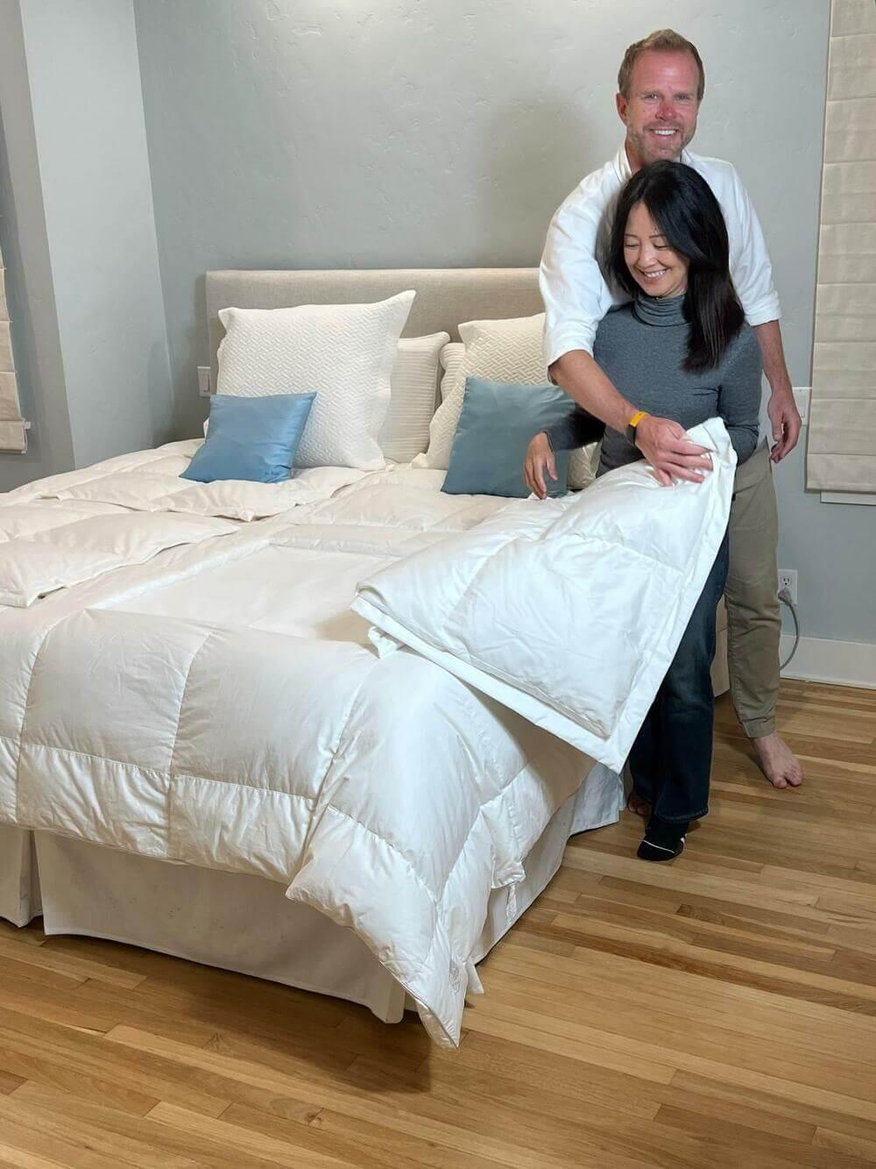
[May 2, 2025 – Beverly Hills, CA] – Sleeping Dove, a comforter company based in California, has introduced a new bedding product specifically created to support those who struggle with nighttime temperature fluctuations—particularly menopausal women and hot sleepers. The launch reflects an increasing focus on sleep wellness and temperature regulation during midlife.
The company’s first product features patent-pending “cooling windows” that give users the ability to discreetly fold away certain sections of insulation without disrupting the entire comforter or their sleeping partner. Each side includes two foldable panels—one near the midsection and another near the feet—providing individualized control over warmth and airflow.
The concept began with co-founder DJ, who experienced heat surges in bed during the early stages of menopause. “I needed a way to cool down in specific areas—without relying on plugs, tech, or synthetic layers,” DJ said. She co-founded Sleeping Dove with her partner James. “We quickly realized it wasn’t just about cooling off. It was about preserving comfort, closeness, and quality sleep, especially for women like me going through physical transitions.”
Sleep disturbances due to fluctuating body temperature and night sweats are common among women in menopause. Many available solutions depend on technology or require separate bedding, but Sleeping Dove’s approach centers on a natural, non-invasive design. The comforter is made using certified organic and recycled materials. While it was created with menopausal women in mind, it has also gained interest from other groups—expectant mothers, pet owners, and couples with differing sleep needs—who want to stay connected without compromising comfort.
“Our goal wasn’t to reinvent the blanket, but to make it more responsive to real-life sleeping needs,” said James, co-founder and product lead. “We wanted something soft, breathable, and flexible—something that supports shared sleep without forcing people to compromise.”
The comforter comes in both down and down-alternative versions and is made with 100% OEKO-TEX® certified cotton. It features heirloom baffle box construction and is filled with either RDS-certified white down or GRS-certified premium microfiber. Sleeping Dove emphasizes sustainable sourcing and long-term durability across all of its offerings.
The Sleeping Dove Comforter is now available in Queen and King sizes exclusively through the company’s website. Sleeping Dove can also be followed via its social media channels @sleepingdovehome.
About Sleeping Dove
Sleeping Dove is a Beverly Hills-based home goods brand rethinking comfort through couple-centered design. Its flagship product—the Sleeping Dove Comforter—features adjustable “cooling windows” to help regulate individual temperatures without sacrificing shared warmth.
Founded by partners DJ and James, the company draws on real-life experiences to create sleep solutions built for comfort, inclusion, and long-term wellness.
Contact Details:
Business: Sleeping Dove
Contact Name: DJ
Contact Email: hello@sleepingdove.com
Website: https://sleepingdove.com/
Country: United States

